22) **main data structures used in protected mode operation**

a) Segment selector

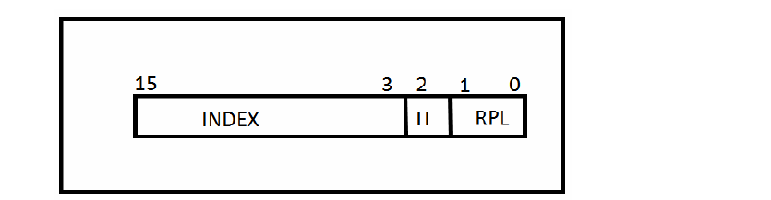

RPL = Request Privilege Level

TI = Table Indicator

INDEX = contains index in table GDT (TI=0) or LTD(TI=1)

Tables can be:

- GTD (Global Description Table)

- LTD (Local Description Table)

- ITD (Interrupt Description Table)

There exist 4 privacy levels, for protecting users and tasks:

Level 0: OS Core

Level 1: System routines

Level 2: OS extensions

Level 3: user tasks

b) Segment descriptor

Can be:

- code and data descriptors

- system descriptors

- gate descriptors

b.1 Code and data descriptors

- can execute only code snippets;

- those segments cannot be written, only read or load instruction code

- data segments can extend to high addresses

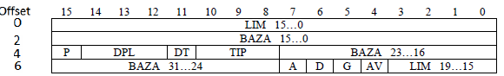

b.2 System descriptors

- were implemented for commuting speed between tasks in the multi-tasking system

- can be of multiple type:

- 0 – invalid descriptor;

- 1 – descriptor TSS (TSS segment available)

- 2 – LTD descriptor;

- 3 – TSS descriptor (TSS segment not available)

b.3 Gate descriptors

- used for **call gates**, which are used for system function calls.

